EF CORE 8.0

Lab 1: Understanding ORM with a Retail Inventory System
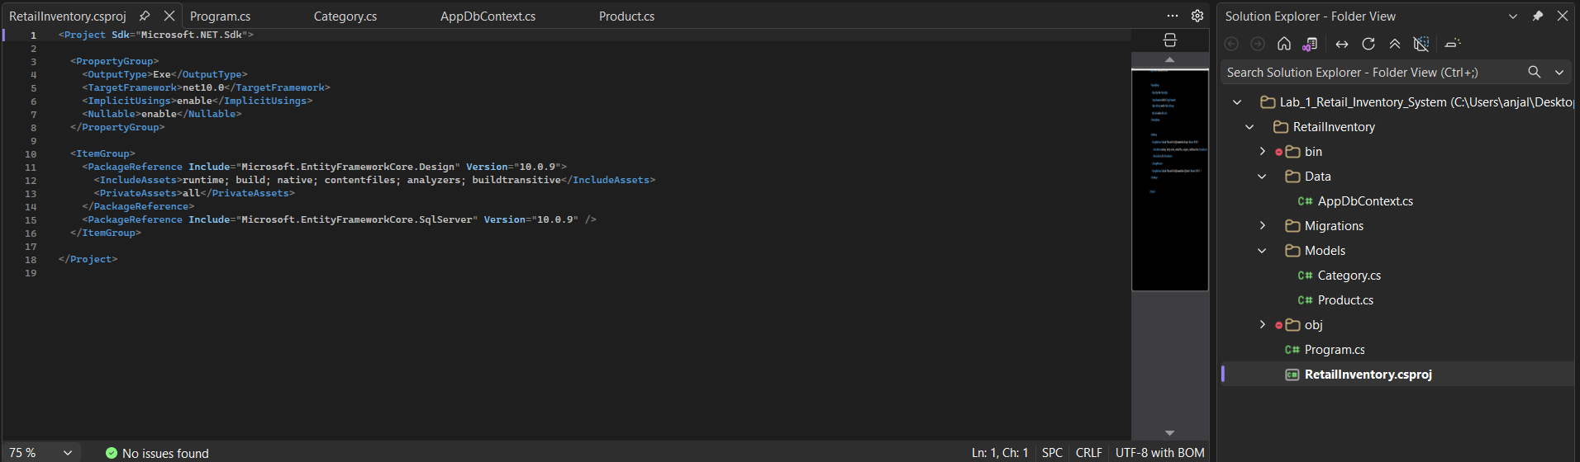

Lab 2: Setting Up the Database Context for a Retail Store
- Product :
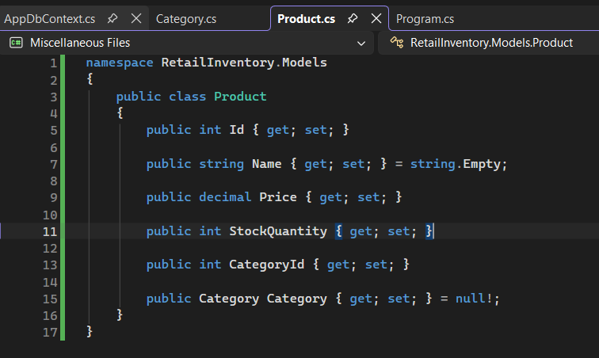
- Category :
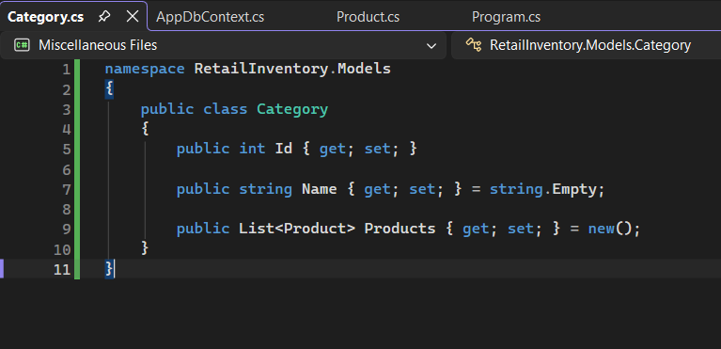

- AppDbContext :
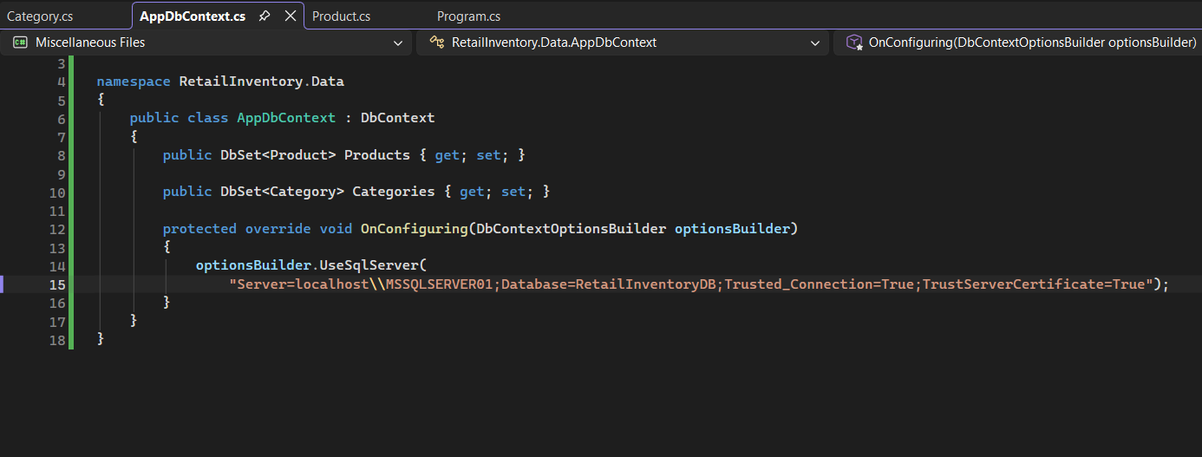

Lab 3: Using EF Core CLI to Create and Apply Migrations
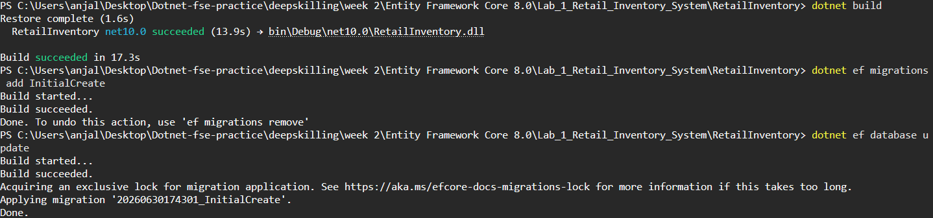
Lab 4: Inserting Initial Data into the Database
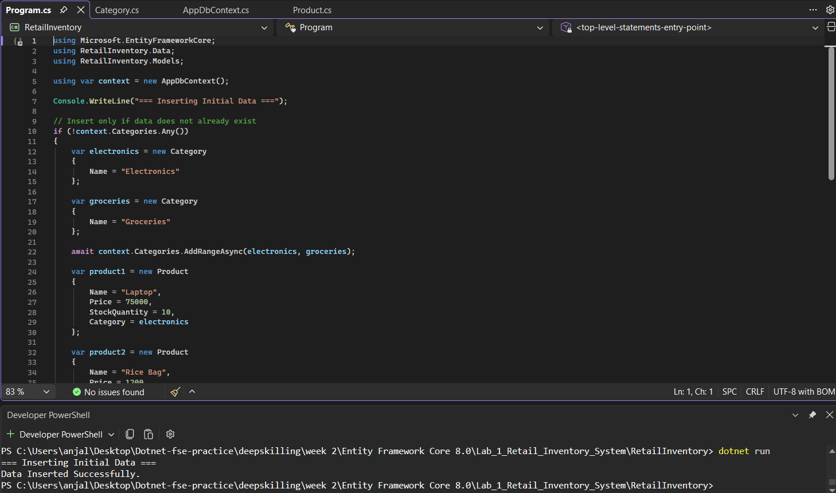

Lab 5: Retrieving Data from the Database
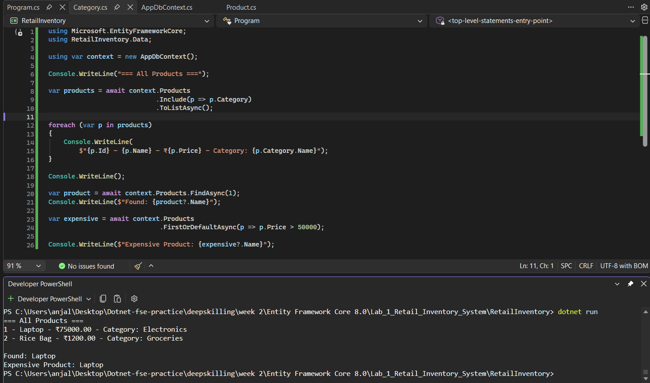

Lab 6: Updating and Deleting Records
